25. The Devil—Track 29 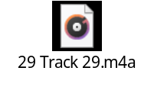
Chaos or the unknown is testing us always. The spiritually driven aspect of our being uses this force to take extreme care not to shoot the messenger. Therefore, when someone creates extreme tension with you in your life, note that her purpose is to aid you in developing further spiritual growth and consciousness; that there are forces beyond the two of you as individuals creating the tension and potential growth opportunity. When you come to understand that the other person is not the problem your perceptions of her, yourself and the workings of the world become transformed.


